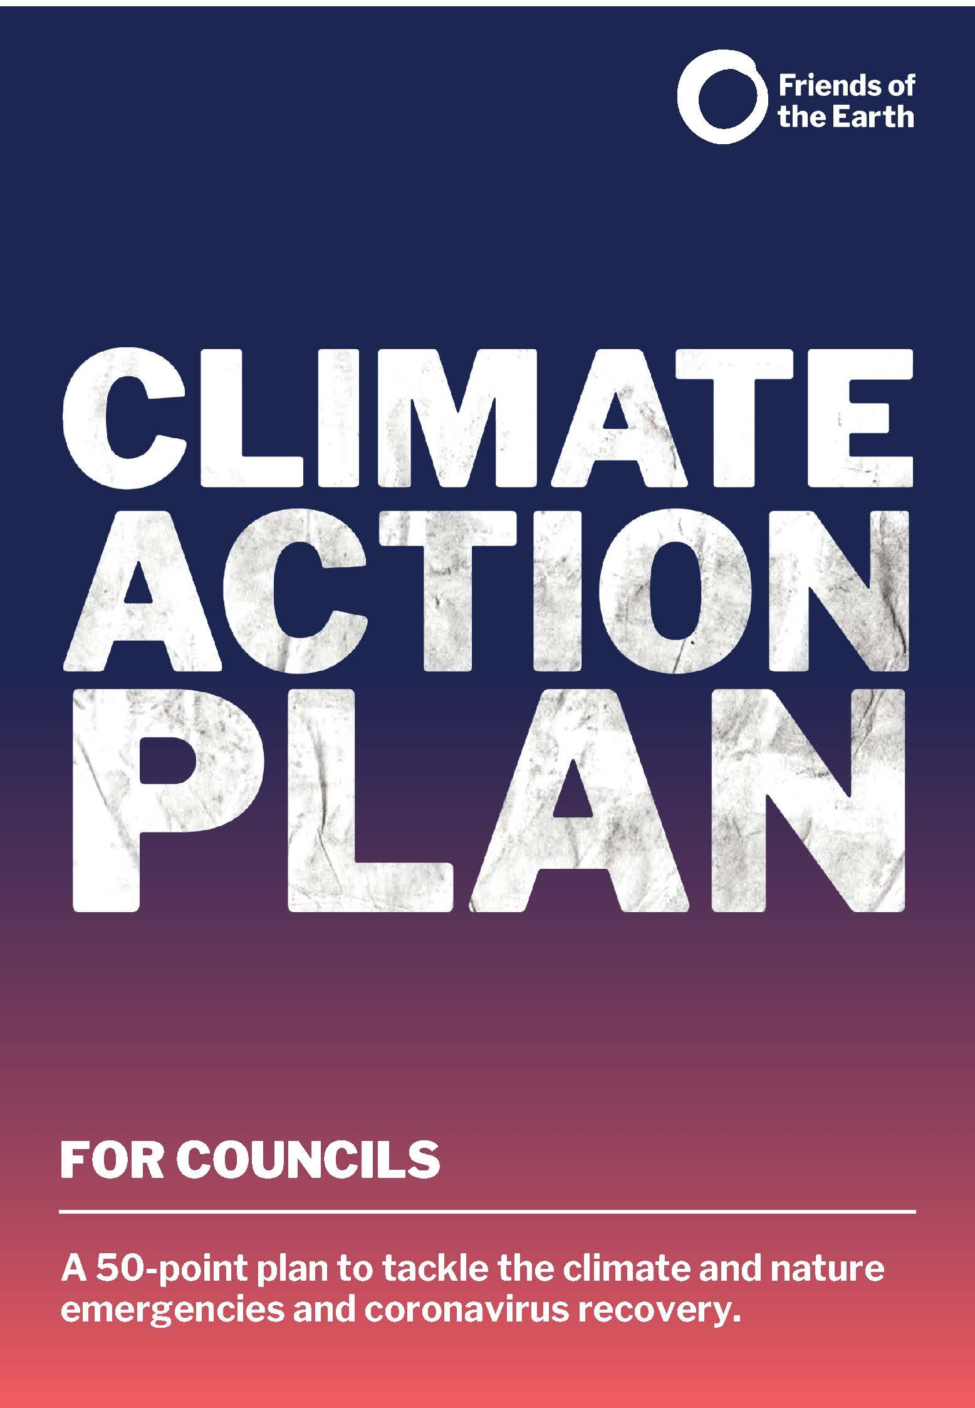

FOR COUNCILS

A 50-point plan to tackle the climate and nature emergency.

Foreword

The news in 2019 was dominated by coverage of the climate and nature crises, and the risks they pose to our lives. More than 240 councils declared a climate and nature emergency in response, committing to cut their greenhouse gas emissions as fast as possible and do what they can to help restore nature.

But since then, our lives have been dominated by the health and economic impacts of the COVID-19 pandemic and more recently the cost-of-living crisis. The government has set out its plans to “level up” the country – tackling longstanding geographical inequalities. Councils are on the front line of all these issues.

But the climate and nature crises haven't gone away. Acting on them can’t be put on the back burner. Fortunately, many of the measures needed to deal with the climate and nature emergencies will also tackle inequalities and benefit our health. These include:

- Improving our housing so that everyone can afford to keep warm in winter and buildings can withstand rising summer temperatures.
- Increasing good quality cycling and walking infrastructure to improve health and reduce carbon emissions and air pollution.
- Increasing the amount and quality of urban green spaces to restore nature, benefit wellbeing and provide connecting corridors for wildlife.

Due to the sheer scale of the inequalities that exist, inequalities that are at risk of increasing as energy bills and food prices rise, a joined-up approach to tackling these crises is vital. For example:

- People who are most marginalised – both in the UK and across the world – have done the least to cause climate breakdown but are the most affected by its impacts.
- People on lower incomes, and particularly people of colour, suffer most from the lack of green space in our towns and cities. The same communities are also more likely to face fuel poverty and suffer more from air pollution, despite being less likely to own a car.
- Young people’s future is most at risk from climate breakdown and the decline of nature, and they’ve been disproportionately impacted by the economic impact of COVID-19, with high levels of unemployment.

This 50-point plan will help councils address the climate and ecological emergencies at the same time as tackling inequalities and boosting local economic recovery in a way that’s green and fair. For further information on each of the themes in this plan, see our Explainer Guides.

What our council will do:

Putting climate and nature at the heart of decision making
Our goal is to ensure that the climate and nature emergencies are a dealbreaker in all our decisions so that we can drastically cut emissions over the next 10 years, and that inclusive engagement with citizens ensures that the changes made are sustainable. We will…

Tick

1 | Check whether all our decisions would help to meet national and local net zero carbon targets, improve air pollution and protect and restore nature, as well as deliver on COVID-19 recovery.
2 | Identify both a councillor at cabinet level and a lead officer as Climate and Nature Champions, who are required to publish an annual independent and audited public report on progress in meeting climate change and nature targets.
3 | Use additional decision-making approaches for complex or contentious choices, such as representative citizen assemblies or citizens’ juries, participatory mapping, and budgeting, etc.
4 | Set interim and measurable targets for our council to rapidly grow the green economy and achieve climate and nature goals.
5 | Align all our council statutory and non-statutory plans, policies and guidance with our climate, nature, and green economy goals, including areas such as procurement and infrastructure development.
6 | Review and improve how we involve citizens in our existing decision-making processes.

Raising money
Our goal is to have sufficient resources to invest in the changes needed to restore nature and meet climate goals, so that our council can reap the dividends and deliver our fair share of reduction in greenhouse gas emissions. We will…

Tick

7 | Introduce a workplace car parking levy and/ or similar initiative to fund and encourage sustainable transport, particularly measures that allow people to travel safely to work, such as segregated cycle ways.
8 | Raise money using bonds, such as Community Municipal Investments (CMIs), for low-carbon infrastructure, particularly measures that speed up carbon emissions reductions and increase resilience to the pandemic, such as energy efficiency and converting roads or car parks to public green space.
9 | Use legal and planning mechanisms such as Section 106 agreements, the Community Infrastructure Levy, and other mechanisms to fund climate actions and nature restoration projects.
10 | Implement licensing of the private rented sector to cover the enforcement costs of ensuring compliance with minimum energy efficiency standards (applicable in England only).

Protect the most vulnerable
Our goal is to ensure that people most vulnerable to the effects of climate change are properly supported and protected. We will…

Tick

11 | Identify the most vulnerable people in neighbourhoods most at risk of extreme weather events and fuel poverty, and with the least good quality green space. Target climate change, nature and pandemic adaptation policies, actions and spending to these people and areas.
12 | Ensure that the voices of the most vulnerable communities are also represented in council decision making and council-citizen deliberations.

Buildings
Our goal is to ensure all homes are well insulated to a minimum of EPC level C, to eradicate fuel poverty as fast as possible, and to install our fair share of the 1 million eco-heating heat pumps that need to be fitted in the UK each year. We will…

Tick

13 | Retrofit council-owned properties with heat pumps and high levels of insulation where possible, starting with homes most at risk of fuel poverty.
14 | Help owner-occupied homes be more energy efficient. For example, by supporting energy companies to provide fuel-poor or vulnerable households with insulation.
15 | Rapidly enforce minimum energy efficiency standards in the private rented sector and encourage landlords to insulate homes to a higher EPC level.
16 | Require through Local Plan policies that new housing development is zero carbon by 2025, including incorporation of renewable energy in the development, using low carbon materials, and building to extremely high energy efficient standards, (higher than current national standards) using the Passivhaus standard or similar.
17 | Enforce compliance with energy efficiency standards set by Building Regulations and with Local Plan policy during construction and renovation, and ensure verification of energy efficiency performance on completion.
18 | Require all the council’s own housing, plus housing built-on council-owned land, to be extremely high energy efficient standards, using the Passivhaus standard or similar.
19 | Develop a heating and energy efficiency strategy for the area, including providing skills and training to increase local employment, and tackle fuel poverty.

Transport
Our goal is to significantly and rapidly increase the proportion of people that travel by cycling, e-bikes and walking, as well as public transport when safe to do so, in order meet World Health Organisation's air pollution standards and climate goals. We will…

Tick

20 | Enable a rapid shift to electric vehicles by installing electric vehicle charging points.
21 | Prioritise transport investment in cycling, walking, trams, and public transport, with a priority of installing segregated cycleways on most roads, increasing space for pedestrians, and introducing a 20 mph speed limit in urban areas.
22 | Put in place Clean Air Zones, with charges if needed.
23 | Reduce car use through measures such as promoting car-sharing, re-regulating bus services and constraining road space.
24 | Require all taxis and buses to be electric.
25 | Deliver a rapid transition of the council’s own fleet to electric vehicles.
26 | Require an electric vehicle or bike to be used for deliveries to the council and encourage greener deliveries across the area by setting up an area-wide distribution centre.
27 | Introduce differential charges for parking permits or other car-related charges.
28 | Reduce the need to own and use a car by requiring that the location and design of new developments be accessible by safe cycling, walking routes and good quality public transport, and situated close to key services.

Energy
Our goal is to enable and support the growth and use of renewable energy, ensure energy is not wasted, and prevent the development of new fossil fuel extraction. We will…

Tick

29 | Significantly grow renewable energy generation by identifying suitable areas in the local plan and/ or by issuing a new Supplementary Planning Document.
30 | Switch street lighting to well-designed and well-directed LED lights.
31 | Reduce energy used by the council in our own estate.
32 | Require the installation of renewable energy such as solar thermal, PV or heat pumps in council developments and within private and public sector developments.
33 | Support the development of renewable energy and energy storage, including by providing skills-training for local workers and encouraging applications for new installations.
34 | Oppose fracking and other fossil fuel extraction, and where opposition to fracking has been overturned, support peaceful protest. (Applicable in England only.)
35 | Divest all investments from fossil fuels, including any pension funds, and invest in renewable energy projects instead.

Waste
Our goal is to be a sustainable consumption and zero-waste area, where all waste is minimised, recycled or reused as part of a circular economy approach. We will…

Tick

36 | Aim to send no waste to landfill or incineration.
37 | Use food waste according to the food waste hierarchy of prevent, reuse, recycle. Ensure remaining non-recyclable biodegradable waste is used to generate biogas.
38 | Adopt circular-economy waste policies in relevant plans and contracts.
39 | Promote community sharing and reuse to reduce waste and unnecessary consumption.
40 | Ban the use of single-use plastic in council offices and premises.

Influencing others
Our goal is to encourage and support other entities with their contribution to addressing the climate and nature emergency and COVID-19 recovery. We will…

Tick

41 | Ensure the Sub-national Transport Body strategy is in line with carbon budgets (applicable in England only).
42 | Use council memberships of Local Enterprise Partnerships to ensure all their decisions are in line with the rapid growth of the green economy, climate reduction pathways and nature restoration plans. (Applicable in England only.)
43 | Provide particular support to small and medium-sized enterprises to access funds and expertise, so they can continue to recover from the COVID-19 pandemic contributing to carbon pollution reduction, nature restoration and the growth of the green economy.
44 | Use influence with others, for example with schools to ensure the buildings are zero-carbon, the environment is central to teaching, and purchasing is green (eg, meals follow the official Eatwell Guide on healthy eating and most menu options are plant-based, with less and better meat or fish as other options).

Land use and nature
Our goal is to ensure everyone has access to nature in nearby green spaces and to restore nature to help draw down carbon pollution from the atmosphere. We will…

Tick

45 | Double tree cover on council-owned land, update local planning strategies to significantly increase tree cover across the local authority area, and ensure existing trees are properly protected, in order to store carbon, support nature, aid flood protection and deliver mental health benefits.
46 | Protect existing local green spaces, the green belt and locally designated nature sites and ensure public access to local authority owned green spaces, including golf courses.
47 | Manage council-owned land and road verges to increase biodiversity and draw down carbon pollution, including through reduced pesticide use and increased planting of wildflowers.
48 | Develop new good quality green spaces in areas which fall short of recommended minimum levels (2 hectares of green space within 5 minutes’ walk), particularly in areas where people have less access to private gardens.
49 | Produce a nature and ecosystem restoration plan to reverse and restore habitats, species, and ecosystem quality and function, in addition to the Local Nature Recovery Strategy.

Campaigning
Our goal is to make our voice heard by the UK government and secure increased devolution to local level and increased democratic control. We will…

Tick

50 | Declare support for the “Blueprint for accelerating climate action and a green recovery at the local level” produced by Friends of the Earth, local government associations and others, which aims to secure more regulatory powers, fundraising powers and finance to deliver our aspirations.

